I added 3 screen shots images to help… (if you receive emails in html format, plain text or rich text might not allow the images to be displayed and you originally sent your email as a rich text, so I changed it to HTML format to include the pictures below….  If the images do not show up and if you want me to resend them as three separate attachments, just let me know..

(( I know the link, username and password all work because I tested it just before I sent this email to you )).

**Download entire Judgment system**

Thank you for purchasing the judgment system - as a download

You have one download, you will need the username and password to open them.  It is zipped file Size: 5.42 MB (5,693,440 bytes). 

**MUST DO:   
Save the file(s) to your computer BEFORE OPENING IT   
     or the download won't finish downloading fully or correctly.**

**\*(Microsoft Bing does not work for me, but Firefox and Chrome did)**

**HERE IS THE LINK TO THE DOWNLOAD:**  
  
Go to this webpage, click the “click here to download” link.

[**https://www.judgmentcenter.com/Download_JudgmentCenter_system_instructions_details.html**](https://www.judgmentcenter.com/Download_JudgmentCenter_system_instructions_details.html)

Get your 259 page main book and everything else (complete system).

Your username is   **(emailed/texted to you separately)**

Your password is    **(emailed/texted to you separately)**Please Type carefully, no extra pixels...

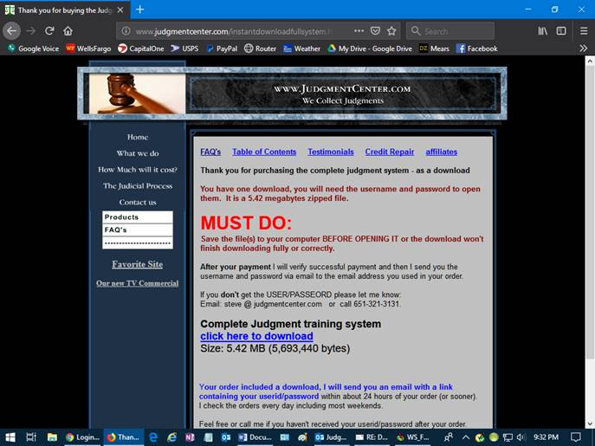

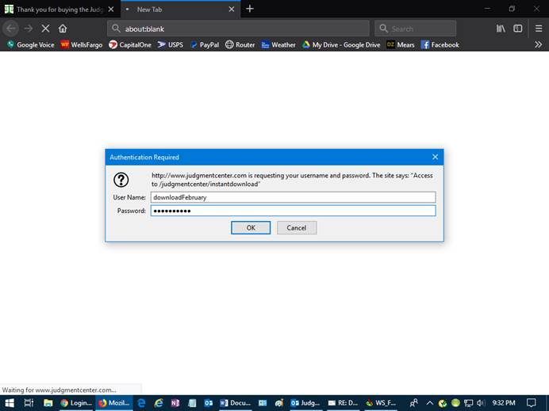

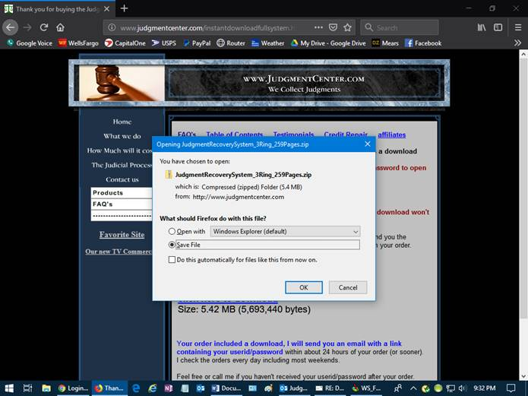

In the meantime, here are notes to look at…..

**Dear New Judgment Collector,**

**Step 1)  Summary of the entire process:**

1. Locate a judgment – many different ways
   1. Go to the courthouse, look in their books for judgments 1-4 years old or so, and from $1000 to $5000 or so.
      1. Find a good judgment in the book, then look up all the information on the computer, writing down everything you see.  Be accurate.
   2. Create a website so they can come to you with their judgments
   3. Advertise in newspapers, websites etc…

Skip any related to family court, child custody, child support.   Most the time there are laws protecting the information you need if in these type of cases.

1. Send a letter to the winner (called judgment creditor).   You might not have a current address for this person/company so you might want to research it first.   The letter should explain what your intentions are.
2. Sometimes the court orders interest and/or fees and sometimes they don’t.  You need to check this out to be able to give the total amount to the winner and loser of the judgment.
3. Mail Forms to the winner (called judgment creditor)
   1. Acknowledgement of Assignment of Judgment (assigns it to you)
   2. Contingency Agreement for Assignment (determines split 50/50% or whatever)
   3. Judgment Debtor Information
4. Research to see if the county needs the judgment moved up to a higher court in order to have the judgment reassigned to someone else.   If they do see what forms they need to do the moving (you might be able to use the enclosed “Affidavit of Identification of Judgment Debtor”).
5. Once you receive the forms back, mail the “Acknowledgement of Assignment of Judgment” back to the courthouse.
6. Once this is received and recorded then you have the right to get any information on the debtor (loser of the judgment).    You are now the judgment creditor assignee.
7. Find the loser.  You can use any free tool or paid tools.  Most are internet based.
8. Ways to get paid for the judgment:
   1. Maybe the judgment debtor (the loser) will be willing to pay on their own, work out a payment plan called installments where they pay something monthly.
   2. If they won’t pay on their own OR if you feel they won’t, then you can and should garnish their pay or levy their bank accounts.
9. Don’t forget to pay the winner the percentage you agreed to in the ” Contingency Agreement for Assignment”
10. Don’t forget that once its paid you need to file a satisfaction of judgment in all counties where the judgment is.   Let the loser know that they need to clean up their own credit report themselves as nothing is removed automatically from the credit bureau even if its been paid in full.

**NOTE:**

Some hyperlinks in the course/system go to links inside the same document, but some go outside (to the internet), and because I can't not control what is on those other websites/webpages please make sure you have virus protection and that includes a firewall (good ones are from MacAfee and Norton).

**Step 2)  Please read the “Judgment_System_Short_Version.pdf” first.   It’s a good summary of the entire course.**

**Step 3)  Then go to the Main System:**    
**How_To_Make_Money_Processing_Judicial_Judgments3RingNotebook259PagesFINAL_LOCKED.pdf**

The links in it are clickable.

**Also:   FormsTemplate.doc:**  modify this form and maybe you can give this out to people that won a judgment to request information about the judgment they won.

**Other Form to start with:**

**AssigningJudgmentForms.doc**

Then the best and first thing you should do is try to find out their current employer for wage garnishment.  If you have a persons SSN, DOB and a current (or slightly older) address you can try to pull their credit report.   Sometimes you can get current/past employer from it so you can try to garnish wages.  If you only get their old employer try to call that company and pretend you’re an old friend and are wondering where they work now.    One of the best judgments to start with are landlord VS tenant disputes.  Most of the time landlords have their ex-tenants application that shows SSN, DOB, vehicle, current/former employer etc…

**Can you create a website like this one for me?**

**Yes.   There are two steps to take:**

**1)  Pick out what domain name you want.  Make sure its unused.**Maybe go to [**www.networksolutions.com**](http://www.networksolutions.com) and see if its available, you don't need to do anything else at this website.

**2)  Pay for your website -** [**http://www.judgmentcenter.com/SampleSitePage.htm**](http://www.judgmentcenter.com/SampleSitePage.htm)**(prices and details)**

**New as of January: Here is a website to find information on debtors:**[**http://www.irbsearch.com/**](http://www.irbsearch.com/)(I used to use [www.accurint.com](http://www.accurint.com/), but they were replaced by <http://www.irbsearch.com/>)

Best Regards,



[**www.JudgmentCenter.com**](http://www.JudgmentCenter.com)

**Steve**

Your Judgment Recovery Processor….

Office (651) 321-1801   Email: [steve@judgmentcenter.com](mailto:steve@judgmentcenter.com)

**And also check out** [**https://www.collectionindustrynews.com/**](https://www.collectionindustrynews.com/)